Restaurants offering takeaway and delivery during COVID-19
Recommended Controls for Your Food Business
The Government have produced a guidance document for restaurants that can be viewed here.
Poster at Entrance
1. Place a poster at the entrance to the premises. We have enclosed some template posters for you to use. You can change the wording to suit your business.
Taking Orders
- No orders should be taken in person on the premises. This should be communicated to customers by appropriate means such as signage and on your website etc. Customers should be encouraged to order online, by app, or by phone. Customers arriving without having already placed an order should be encouraged to leave the premises to place their order by telephone or online, and to return at a designated time for collection.
Payments
- It is difficult to maintain social distancing between the customer and staff when paying so we recommend you consider taking only contactless payments where possible. For food delivery orders we recommend you take payment over the phone or online at the time of ordering to reduce drivers having to take card or cash payments on delivery.

For Takeaway Food Collections
- You must limit the number of people in the premises.
- If customers are entering the premises to collect food, you must consider whether screens or other controls are necessary where the 2-metre rule cannot be adhered to.
- You need to consider how you will manage customers while they are waiting to collect their order. Customers should be given staggered collection times to reduce queuing and should be discouraged from entering the premises until their order is ready.
- You will also need to consider having a ‘safe zone’ for customer collections. This might be a section of the counter where food can be handed over or left but you will need to ensure social distancing or other controls such as a screen are in place.
Floor marking
- To help customers to keep their distance, mark lines on the floor 2m apart (starting at the till). You can buy yellow and black floor tape on line (several businesses sell this).
Stewarding
- At busy times you may need a member of staff to manage customers waiting and to control entry.
Shop Doors
- In order to minimise the surfaces that could become contaminated you may wish to consider whether it is easier to keep the door wedged open so customers do not need to touch it. However, this will need to be considered in conjunction with restricting access to customers as above.

For delivery food services
- Delivery staff should wash their hands-on arrival before touching any food packaging, and each time they return to the preemies. You must also provide a hand hygiene kit (sanitise gel or wipes etc) for drivers to use when they are delivering food. Gels should not be left in hot cars as this can affect the alcohol content and render the gel useless.
- You will need to put in place arrangements for safe delivery of food at the destination, taking account of social distancing, and food hygiene. One method could be for the driver to place the packaged in a suitable location by the door, knock the door and then step back 2 metres while the customer collects the food. Once the door is closed, the driver can then recover and remove any reusable packaging such as insulated boxes or bags. Any reusable bags and boxes should be wiped down between uses.
Food Preparation and Service Areas
- You must implement controls so all staff can work in a safe way that enables social distancing at all times. This may be by allocation tasks with time separation; reducing menus; reducing staff numbers on any shift; redesigning the layout of kitchen and counter areas; or any other methods. If you are not able to ensure effective controls, you should not continue trading.

Personal hygiene and hand washing

It is essential that staff are able to wash their hands frequently.
Hand washing facilities
- Ensure the area where the hand washing facilities are sited is clean and hygienic. This is usually by the staff toilet so this area and facilities must be disinfected at the start and end of the day.

- The hand drying must be a single use disposable towel eg paper towel or blue paper roll. This should be placed in a dispenser which is fitted to the wall. A reusable cloth towel is NOT acceptable.

- Liquid soap must be available at the wash hand basin. Make sure you have a plentiful supply.

Effective hand washing
- Ensure that staff wash their hands properly (using the correct technique and for, at least, 20 seconds – see the link to a video at the end of this letter). This must be done before starting work, after coughing or sneezing or blowing their nose, before and after restocking shelves, after a break or touching their phone and before leaving the shop.
Note: You and your staff must wash your hands properly after blowing their nose or coughing into their hand BEFORE they touch any other surfaces. Hand sanitiser is no substitute.

Healthy hands
- You should provide hand moisturiser and / or barrier cream to reduce the risk of dermatitis.

Clothing
- You and your staff should wear a clean uniform which they ideally change into when they arrive at work and take off before leaving work or be provided with an apron. Bear in mind that the virus may survive on clothing for up to 3 days.

Hand hygiene for customers
- You may wish to consider providing hand sanitiser for customers to use before entering the premises.

- A poster is enclosed for your use which says “For the safety of everyone, please use this hand sanitiser before entering. Do not enter if you are ill”

Contamination of food and packaging
- For all takeaway and delivery food we recommend new food grade disposable packaging is used.

Taking money and giving change
- You should encourage contactless payments wherever possible. This can be online or contactless card payments. Put the enclosed poster at the entrance which says “Please use contactless payment if you are able to do so. Contactless payment is available for purchases up to £45”. In some instances, contactless card payment machines can operate through glass or a clear screen so if you have one in place at the till, give it a try.

- If you do continue to accept cash payments you will need to consider how this is managed to reduce risks. This could include the operator wearing a glove (must be changed regularly), using a tray or dish for cash to be put in when passing between people.

- Provide a plastic washable cover for the keys on the till to enable thorough cleaning. Disinfect throughout the day (covers cost £20-30) or you could use cling film.

Management
- Make sure staff know what the procedures and supervise them. You should write this down and use it to train your staff.

- Review your start-up checks and closing checks to include all necessary checks.

- Review your cleaning schedule to include disinfection of all key touch points and contact surfaces etc.

Covid-19 infection Control for all Food Businesses Supplying
Takeaway or Food Deliveries
You are required to ensure the safety of yourself, your employees and your customers.
The Covid-19 virus is HIGHLY CONTAGIOUS and it STICKS TO SURFACES (eg packaging, counter top, money and skin) and can survive for around to 3 days.
It easily passes from one person to another through
the air; if a person coughs, the virus is catapulted onto surfaces (that is why you must cough into the crook of your elbow or into a tissue then wash your hands immediately).
If someone is too close, you might breathe in the infected droplets & become ill.
If you touch a contaminated surface, your hands may become contaminated. Once contaminated, hands can transfer the virus to your eyes, nose or mouth. From there, the virus can enter your body and you may become ill.
Remember: if you touch a surface that someone else has touched, there’s a risk of infection
When you are deciding what controls are needed, assume that you, your staff and your customers may all be infected and assume everyone’s hands and money may be contaminated.
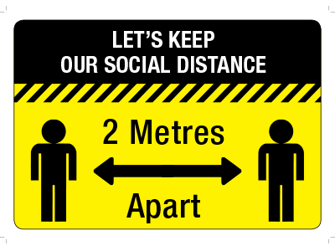
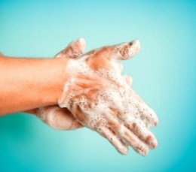
The rules are simple, you MUST …
- Stay 2m apart
- Wash your hands before touching your face
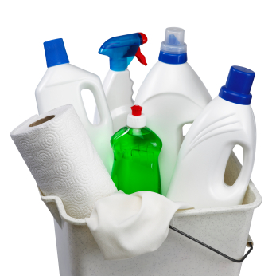
- De-contaminate surfaces regularly*; wash the surface then disinfect it. Use alcohol wipes if you have them, if not use a sanitiser (spray onto the surface and wipe, spray again and leave for 5 mins).

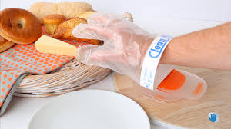
Do not touch surfaces with your hands. You may decide to wear gloves – these can be tricky to get on and off. There are various types of gloves. Some are designed as a loose-fitting glove that allows you to slide your hand in / out easily. However, you must keep gloves clean and replace them regularly.
*An effective way of decontaminating surfaces is to use a bleach solution but care must be taken when handling this chemical. Wear protective gloves. Mix 10ml (about 2 capfuls) of thick bleach with 1 litre of water.
Social distancing

In line with government advice, everyone must remain 2 metres apart. This is to reduce the risk of transferring the virus from an infected person to another person (sometimes people have the virus and feel well so they don’t realise they are infected)

In order to maintain this rule you must make sure that all staff, customers (and delivery personnel) are kept apart.

For the safety of everyone, please use hand sanitiser
before entering.
Do not enter if you feel unwell, or have a cough or you’re sneezing (even if you think its hay fever).

CUSTOMER NOTICE
Please note we are only taking orders and payment in advance by telephone or online

Please respect our safety and do not enter without having placed an order in advance.

Social distancing.
To protect our customers and staff at this time, we are actively managing the number of customers who can come into our premises at any one time.

Please make sure you stand 2m (6 feet) apart using the marked lines on the floor.

When at the front wait behind the line until called forward.

Thank you for your understanding & co-operation.

CUSTOMER NOTICE
While queueing for your order please keep 2 metres
between yourself & the
person in front of you.
We aim to serve you as soon as possible.

Please use contactless payment if you can

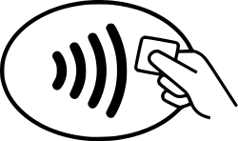
Contactless payment is now available for purchases up to £45
Keep Your Distance
2m away

CUSTOMER NOTICE
Do not enter the exclusion zone around the counter

Follow the arrow this way

Follow the arrow this way

Follow the arrow this way

