Help us

save lives…

Do you want to:
- Be part of something that helps save lives?
- Meet new people?
- Help save the planet by encouraging pre-loved?
- Gain flexible work experience for your CV?
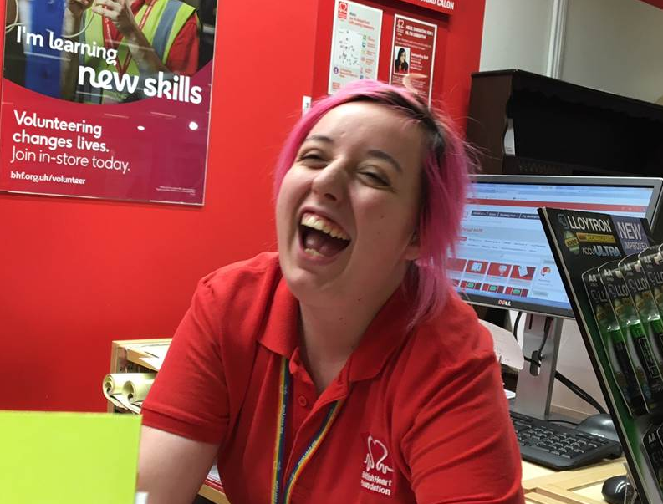
Volunteer at the
Northampton
British Heart Foundation store
Be part of a friendly team where you can:
- Get out of the house and try something new
- Socialise with other volunteers & local customers
- Choose your own shifts - 3 hours is a huge help!

Contact the Helen at robinsonhel@bhf.org.uk or call 07789 651681 for an

www.bhf.org.uk
©British Heart Foundation 2019, a registered charity in England and Wales (225971) and Scotland (SC039426).
BHVO175
informal chat and more information - join our BHF family!

