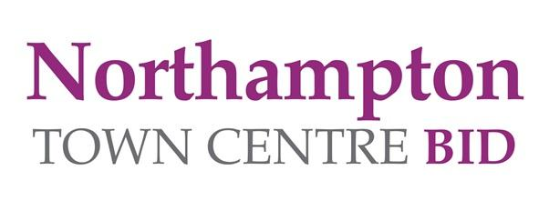

NORTHAMPTON TOWN CENTRE BID –
PAW PATROL BRICK TRAIL PRIZE DRAW 2022

Terms & Conditions:
- Multiple entries will be disqualified.
- The prize draw is open to Northamptonshire residents only.
- All official entries must be made in the name of a person who is over 16 years and must not work for or be a director of Northampton Town Centre Ltd (Business Improvement District) to enter.
- We are giving away £200 – four winners will receive £50 of gift vouchers to spend in a town centre business of their choice.

- Trail Maps are being issued by selected retailers around the town centre. Simply complete required details on reverse and enter into our specially designed post box, located in Grosvenor Shopping Northampton.
- The Paw Patrol Brick Trail entry post box is located in Grosvenor Shopping Northampton. This post box will be available to you until 9 am on Monday 28 March 2022
- Only fully completed entry forms will be entered into the prize draws.
- The prize draw will take place on Monday 28 March 2022 at Midday.
- Winners will be contacted via telephone – three attempts to contact the winners will be made during the period Monday 28 March to Thursday 31 March. Prizes not claimed by 5 pm on Thursday 31 March will be reallocated. In the event of these attempts being unsuccessful the entry will become void and a new winner will be drawn
- Winners will be chosen at random from all valid entries.
- The Judge’s decision is final and no correspondence will be entered into.
- The four winners who are selected to win one of the prizes of shopping vouchers will receive 1x £50 of gift vouchers for their selected retailer/business within Northampton town centre. The expiry date for your voucher will be in accordance with the business’s terms and conditions. Once issued the vouchers are not refundable or exchangeable in the event of a business closure.

- Vouchers will be issued within 2 weeks of the winners selecting their businesses.
- Vouchers cannot be issued in any other currency and cannot be exchanged for cash. No change will be given if the full value of the voucher is not spent in one visit at the nominated store(s).
- Winners or their representative will be required to have their photograph taken for local press and PR purposes. The photo shoot will take place within Northampton Town Centre.
- Your data will only be used to communicate with you if you have won a prize. Entrants have the option to opt in to receiving future updates by email about Northampton Town Centre BID events and promotions. Your data will not be shared with any third party.

