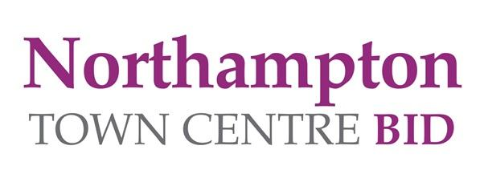

NORTHAMPTON TOWN CENTRE BID –
NORTHAMPTON CHRISTMAS PRIZE DRAW 2023

Terms & Conditions:
- Multiple entries will be disqualified.
- The prize draw is open to Northamptonshire residents only.
- All entrants must be over 16 years and must not work for or be a director of Northampton Town Centre Ltd (Business Improvement District) to enter.
- This Christmas we are giving away £2,000 – four winners will receive £500 of gift vouchers to spend in the town centre businesses of their choice.

- Golden Tickets are being issued by selected retailers around the town centre. Simply complete required details on the reverse of the ticket and enter into one of our 10 post boxes.
- The Golden Ticket Post boxes are located in businesses around the Town Centre. These post boxes will be available to you until 12pm on Sunday 17th December.
- Only fully completed entry forms will be entered into the prize draw.
- The prize draw will take place on Monday 18th December 2023.
- Winners will be contacted via telephone – three attempts to contact the winners will be made on Monday 18th December. Prizes not claimed by 5pm on Tuesday 19th December will be reallocated. In the event of these attempts being unsuccessful, the entry will become void and a new winner will be drawn.
- Winners will be chosen at random from all valid entries.
- The Judge’s decision is final and no correspondence will be entered into.
- The four winners who are selected to win one of the prizes of shopping vouchers will receive 1x £250 of gift vouchers for their selected corporate retailer/business within Northampton town centre and 1x £250 gift voucher for their selected independent retailer/business within Northampton town centre. The expiry date for your voucher will be in accordance with the business’s terms and conditions. Once issued the vouchers are not refundable or exchangeable in the event of a business closure.

- Vouchers will be issued within 2 weeks of the winners selecting their businesses.
- Vouchers cannot be issued in any other currency and cannot be exchanged for cash. No change will be given if the full value of the voucher is not spent in one visit at the nominated store(s).
- Winners or their representative will be required to have their photograph taken for local press and PR purposes. The photo shoot will take place within Northampton Town Centre.
- Your data will only be used to communicate with you if you have won a prize. Entrants have the option to opt-in to receiving future updates by email about Northampton Town Centre BID events and Christmas Promotions. Your data will not be shared with any third party.

