Suggested social media copy

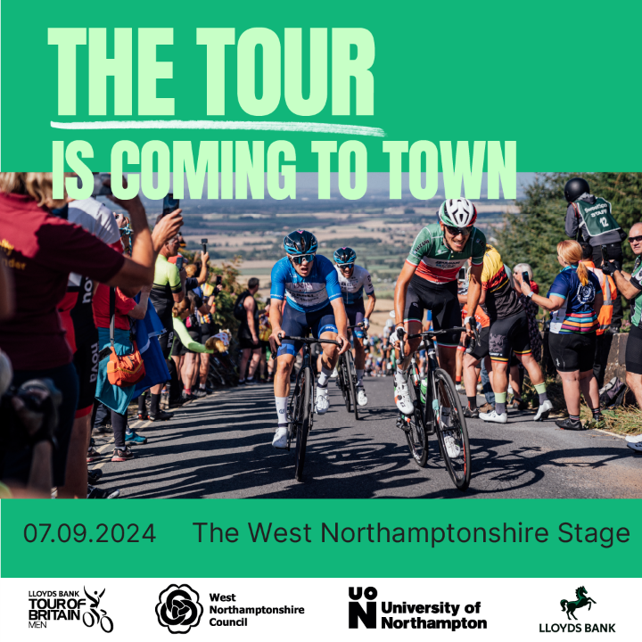 | The Tour is coming to town!  Join us on Saturday 7 September as we welcome the Lloyds Bank Tour of Britain Men to West Northamptonshire.  To celebrate… [insert any promotions/offers]  Find out more about the event here: www.westnorthants.gov.uk/tour-britain-men
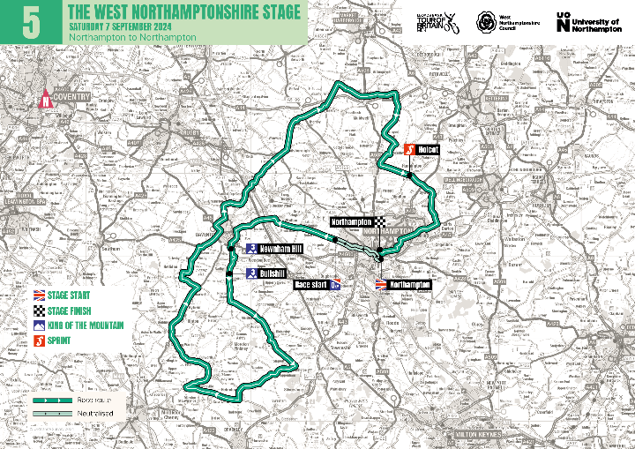 | [Insert business name] is getting ready to welcome the Lloyds Bank Tour of Britain Men to West Northamptonshire!  Join us on Saturday 7 September to cheer on the cyclists as they ride 147 kilometres (91 miles) through the area.  To celebrate… [insert any promotions/offers]  Find out more about the event here: www.westnorthants.gov.uk/tour-britain-men

